Asymmetric DCC correlation: GBPUSD and USDCHF
Method 10 / GARCH(1,1) + Cappiello-Engle-Sheppard ADCC / Alpari D1 full available history

Study setup
Logical pair: GBPUSD , USDCHF
Broker symbols: GBPUSD_i , USDCHF_i
Snapshot: 2026-11-03_majors_alpari_D1
Timeframe: D1
Matched return window: 1999-01-05 to 2026-11-02 (UTC bar dates)
Matched return count n: 7201
Dropped unfinished last bar dated 2026-11-03 UTC after a tick-volume check against the prior complete day.
GBPUSD GARCH(1,1): mu=0.000021, omega=0.003995, alpha=0.055119, beta=0.932591
USDCHF GARCH(1,1): mu=-0.000354, omega=0.003266, alpha=0.042706, beta=0.955814
ADCC: a=0.007461, b=0.991681, g=0.000020, a+b+g/2=0.999151
Nested DCC (g=0): a=0.007399, b=0.991601
Negative shock: n = min(z, 0) in broker quote direction (not inverted)
Burn-in ignored in path summaries and chart: first 60 updates
Complete matched rows (Excel): GBPUSD-USDCHF_ADCC_D1.xlsx
Complete matched rows (HTML table): GBPUSD-USDCHF_ADCC_D1_data.html

Method carried forward
Asymmetric DCC extends Engle DCC with an extra term on joint negative standardised shocks. Each matched daily log return of close, ln(close_t / close_t-1), is first filtered by a constant-mean GARCH(1,1). Then z = residual / sigma and n = min(z, 0). The Cappiello-Engle-Sheppard recursion uses A = (1-a-b) Q_bar - g N_bar with N_bar = mean(n n'). Quotes are not inverted, so a negative shock is a negative log return in the broker quote. Nested symmetric DCC (g = 0) is fit on the same z path for comparison. Constraints: a,b,g >= 0 and a + b + g/2 < 1. Path summaries ignore the first 60 updates. The headline is latest ADCC rho. Pearson r is a side check only. This is not a cause, lead, or trading signal.

Results
Latest ADCC rho: -0.681545
Latest nested DCC rho: -0.677422
Post-burn-in ADCC path (n=7141): mean=-0.538762, median=-0.540088, min=-0.828087, max=-0.096971, std=0.138332
Share of post-burn-in days with |rho| >= 0.4: 86.04%; |rho| >= 0.7: 13.56%
Same-sample Pearson r: -0.486083
ADCC minus r: -0.195462
ADCC minus nested DCC: -0.004123

Conclusion
Over 7201 matched daily log-return rows for GBPUSD and USDCHF (broker quote directions unchanged), latest ADCC rho is -0.6815 (negative, moderate conditional linear link in this sample) with fitted a=0.0075, b=0.9917, g=0.0000. Nested symmetric DCC latest rho is -0.6774 (ADCC minus DCC = -0.0041). After a 60-day burn-in, path mean is -0.5388 and std is 0.1383. Same-sample Pearson r is -0.4861 (ADCC minus r = -0.1955). This does not establish cause, lead-lag, or a lasting trading rule.

Charts
Daily closes

Daily log returns
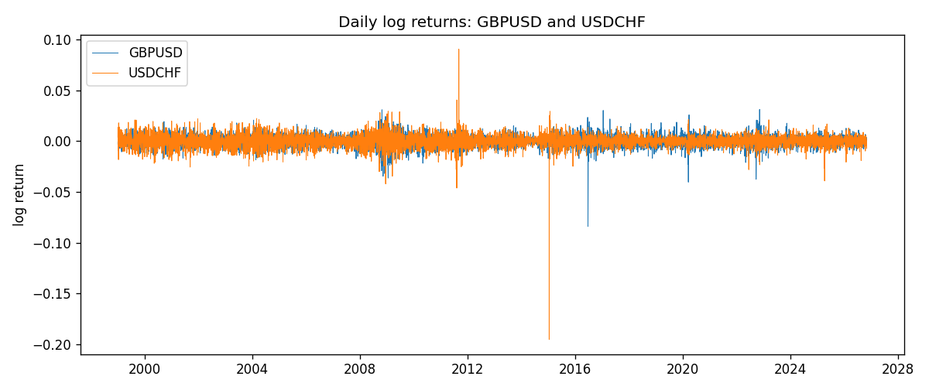
ADCC rho path with nested DCC and Pearson r
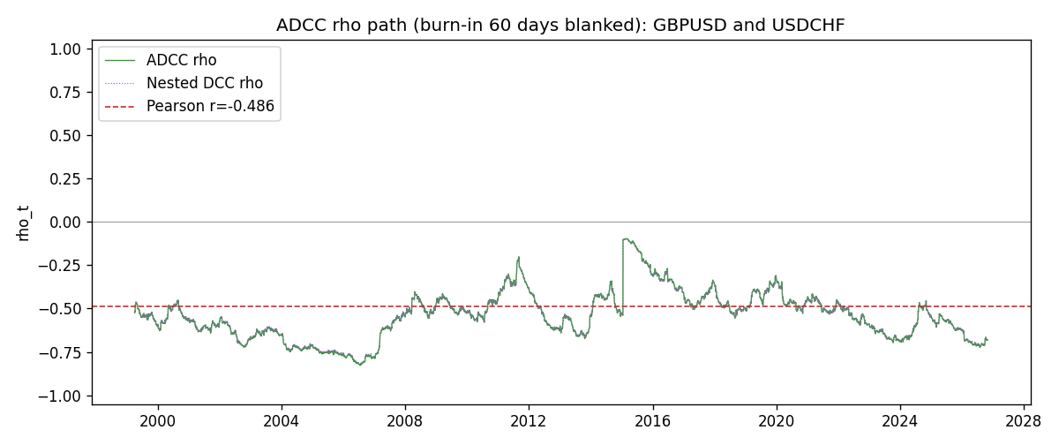

Data report
Every matched row that entered the ADCC recursion is stored in the sibling Excel workbook named GBPUSD-USDCHF_ADCC_D1.xlsx. Embedding all rows as a Word table is impractical at this length; the Word file holds the column list, column summaries, and the first and last 15 matched rows.
Columns: time, GBPUSD_open, USDCHF_open, GBPUSD_high, USDCHF_high, GBPUSD_low, USDCHF_low, GBPUSD_close, USDCHF_close, GBPUSD_tick_volume, USDCHF_tick_volume, GBPUSD_spread, USDCHF_spread, GBPUSD_real_volume, USDCHF_real_volume, GBPUSD_log_return, USDCHF_log_return, GBPUSD_sigma, USDCHF_sigma, GBPUSD_z, USDCHF_z, GBPUSD_n, USDCHF_n, q11, q22, q12, rho_adcc, rho_dcc
Column summaries (matched calculation rows)
column | count | mean | std | min | 25% | 50% | 75% | max
GBPUSD_open | 7201 | 1.5160785 | 0.218271 | 1.06854 | 1.32499 | 1.51142 | 1.63167 | 2.1066
USDCHF_open | 7201 | 1.0982956 | 0.25264095 | 0.72022 | 0.92069 | 0.99019 | 1.2387 | 1.8219
GBPUSD_high | 7201 | 1.5223771 | 0.21884011 | 1.08366 | 1.32979 | 1.5182 | 1.6384 | 2.1161
USDCHF_high | 7201 | 1.1035944 | 0.25438893 | 0.73305 | 0.92495 | 0.99377 | 1.2436 | 1.8313
GBPUSD_low | 7201 | 1.5097512 | 0.21749696 | 1.03518 | 1.31949 | 1.50336 | 1.6244 | 2.0983
USDCHF_low | 7201 | 1.0931703 | 0.25105533 | 0.08565 | 0.91742 | 0.9867 | 1.2331 | 1.8121
GBPUSD_close | 7201 | 1.5161456 | 0.2182303 | 1.06879 | 1.3251 | 1.5114 | 1.63212 | 2.1065
USDCHF_close | 7201 | 1.0982864 | 0.25254184 | 0.72025 | 0.92098 | 0.9902 | 1.2387 | 1.8217
GBPUSD_tick_volume | 7201 | 94828.085 | 153546.21 | 62 | 10002 | 52900 | 91806 | 1273370
USDCHF_tick_volume | 7201 | 74189.26 | 113409.95 | 18 | 12770 | 40195 | 70240 | 858589
GBPUSD_spread | 7201 | 26.971115 | 19.193539 | 0 | 11 | 20 | 50 | 50
USDCHF_spread | 7201 | 26.114567 | 24.723753 | 0 | 5 | 16 | 50 | 100
GBPUSD_real_volume | 7201 | 3.5560898e+09 | 8.4438214e+10 | 0 | 0 | 0 | 0 | 2.4038164e+12
USDCHF_real_volume | 7201 | 2.3236557e+10 | 8.9041498e+10 | 0 | 0 | 0 | 0 | 1.9331921e+12
GBPUSD_log_return | 7201 | -2.316e-05 | 0.00564524 | -0.08388241 | -0.00312969 | 3.242e-05 | 0.00318104 | 0.03112653
USDCHF_log_return | 7201 | -7.148e-05 | 0.00659332 | -0.19545699 | -0.00335964 | 8.06e-05 | 0.00331782 | 0.09051364
GBPUSD_sigma | 7201 | 0.00539712 | 0.00169157 | 0.00300411 | 0.0044801 | 0.00504063 | 0.00577094 | 0.0219492
USDCHF_sigma | 7201 | 0.00655186 | 0.0025883 | 0.00354625 | 0.00506186 | 0.0061083 | 0.00733966 | 0.04070609
GBPUSD_z | 7201 | -0.00702038 | 1.0000195 | -10.319789 | -0.60085909 | 0.00251205 | 0.60639205 | 4.9458385
USDCHF_z | 7201 | 0.04142072 | 0.99902916 | -34.238169 | -0.48191864 | 0.07224301 | 0.59885642 | 6.680756
GBPUSD_n | 7201 | -0.38646987 | 0.60998373 | -10.319789 | -0.60085909 | 0 | 0 | 0
USDCHF_n | 7201 | -0.33021868 | 0.67753182 | -34.238169 | -0.48191864 | 0 | 0 | 0
q11 | 7201 | 1.0030759 | 0.11774484 | 0.68602091 | 0.93818171 | 0.99108323 | 1.043889 | 1.9485444
q22 | 7201 | 1.0031999 | 0.76510514 | 0.60342218 | 0.79624315 | 0.88156765 | 0.94846301 | 9.5876337
q12 | 7201 | -0.50842621 | 0.11917491 | -0.82202747 | -0.59001171 | -0.50366591 | -0.42662583 | -0.22120437
rho_adcc | 7201 | -0.53864079 | 0.13776304 | -0.82808709 | -0.62931256 | -0.53867158 | -0.45997784 | -0.09697148
rho_dcc | 7201 | -0.53786861 | 0.13556829 | -0.82232712 | -0.62709413 | -0.53797532 | -0.46088756 | -0.09879783
First 15 matched rows (selected columns)
time | GBPUSD_log_return | USDCHF_log_return | GBPUSD_z | USDCHF_z | GBPUSD_n | USDCHF_n | q11 | q22 | q12 | rho_adcc | rho_dcc
1999-01-05 | -0.0028966287 | 0.0039424743 | -0.7132503 | 0.51213724 | -0.7132503 | 0 | 1 | 1 | -0.50922947 | -0.50922947 | -0.50922947
1999-01-06 | -0.00060452184 | 0.013605652 | -0.15410824 | 1.6881586 | -0.15410824 | 0 | 0.99633441 | 0.99448489 | -0.50815624 | -0.51049984 | -0.51048566
1999-01-07 | -0.002118709 | -0.0093883841 | -0.53856561 | -1.0502371 | -0.53856561 | -1.0502371 | 0.98907148 | 1.0083214 | -0.50630763 | -0.50699203 | -0.50700073
1999-01-08 | -0.0058954193 | 0.011040268 | -1.5090127 | 1.3196638 | -1.5090127 | 0 | 0.98386104 | 1.0090311 | -0.49830229 | -0.50011943 | -0.50019703
1999-01-11 | -0.0056851331 | 0.0052963193 | -1.3977921 | 0.64336697 | -1.3977921 | 0 | 0.99355804 | 1.0144772 | -0.50945219 | -0.50744112 | -0.5074638
1999-01-12 | 0.0022657001 | -0.0098275602 | 0.53302226 | -1.0910055 | 0 | -1.0910055 | 1.000756 | 1.009973 | -0.51236131 | -0.50963277 | -0.50964115
1999-01-13 | 0.0091330396 | -0.018259701 | 2.1960282 | -2.0508212 | 0 | -2.0508212 | 0.99539834 | 1.011322 | -0.51287543 | -0.51117396 | -0.51116923
1999-01-14 | 0.0019376331 | -0.0024256692 | 0.417928 | -0.22228693 | 0 | -0.22228693 | 1.023946 | 1.0352174 | -0.5426479 | -0.52706454 | -0.52694695
1999-01-15 | -0.0017558204 | 0.01794228 | -0.39516611 | 2.0015708 | -0.39516611 | 0 | 1.0175789 | 1.0278221 | -0.53926443 | -0.5273012 | -0.52717342
1999-01-18 | 0.0012112405 | -0.0031856384 | 0.27004747 | -0.29134171 | 0 | -0.29134171 | 1.0111297 | 1.0500091 | -0.54111721 | -0.52515969 | -0.52504232
1999-01-19 | 0.0018745281 | -7.2518946e-05 | 0.42983778 | 0.029479496 | 0 | 0 | 1.0041101 | 1.042756 | -0.53764036 | -0.52542392 | -0.52529655
1999-01-20 | -0.0049053846 | 0.0072259871 | -1.1633909 | 0.81128237 | -1.1633909 | 0 | 0.99798331 | 1.0349348 | -0.5335109 | -0.52495872 | -0.52482685
1999-01-21 | 0.0031518998 | -0.0038232689 | 0.72873059 | -0.37367255 | 0 | -0.37367255 | 1.0006536 | 1.0320828 | -0.53655221 | -0.52797437 | -0.52781771
1999-01-22 | 0.0024781662 | -0.0001445609 | 0.57669439 | 0.022922723 | 0 | 0 | 0.99713918 | 1.0253884 | -0.534558 | -0.52865548 | -0.52848559
1999-01-25 | 0.0012066366 | 0.0024546976 | 0.28211708 | 0.31419766 | 0 | 0 | 0.99217322 | 1.0177091 | -0.53045009 | -0.52788453 | -0.52771229
Last 15 matched rows (selected columns)
time | GBPUSD_log_return | USDCHF_log_return | GBPUSD_z | USDCHF_z | GBPUSD_n | USDCHF_n | q11 | q22 | q12 | rho_adcc | rho_dcc
2026-10-13 | 0.0036434319 | -0.0024955621 | 0.98697999 | -0.45185008 | 0 | -0.45185008 | 0.82071078 | 0.78447909 | -0.53708828 | -0.66936026 | -0.66542874
2026-10-14 | -0.0049164679 | 0.0029388325 | -1.334661 | 0.70198459 | -1.334661 | 0 | 0.82199917 | 0.78032738 | -0.53638527 | -0.66973459 | -0.66578492
2026-10-15 | 0.0065976411 | -0.0097855323 | 1.7267527 | -2.019306 | 0 | -2.019306 | 0.82933397 | 0.77835953 | -0.53935099 | -0.67129997 | -0.66734794
2026-10-16 | 0.0037592051 | -0.0036230826 | 0.92558306 | -0.6541596 | 0 | -0.6541596 | 0.8455287 | 0.80323359 | -0.56131681 | -0.68111891 | -0.67717724
2026-10-19 | -0.0017500314 | 0.0036351779 | -0.43755581 | 0.80329468 | -0.43755581 | 0 | 0.84573451 | 0.80059964 | -0.56160233 | -0.68250239 | -0.67853346
2026-10-20 | 0.0055923442 | -0.0026281224 | 1.3994149 | -0.45880754 | 0 | -0.45880754 | 0.840979 | 0.79960093 | -0.55999046 | -0.68289103 | -0.67889901
2026-10-21 | 0.0012476328 | -0.00040027413 | 0.29845956 | -0.0094992368 | 0 | -0.0094992368 | 0.84944202 | 0.7953708 | -0.56055996 | -0.68197802 | -0.67799651
2026-10-22 | 0.00022396082 | -0.0048036381 | 0.050379133 | -0.92187275 | 0 | -0.92187275 | 0.8438881 | 0.78960188 | -0.55635551 | -0.68156279 | -0.67755144
2026-10-23 | -0.0021146949 | 0.005652514 | -0.54170454 | 1.2404882 | -0.54170454 | 0 | 0.83773472 | 0.79023751 | -0.5525114 | -0.67906158 | -0.67506964
2026-10-26 | -0.0024340661 | 0.0018407959 | -0.63081755 | 0.4454101 | -0.63081755 | 0 | 0.83380868 | 0.79599153 | -0.55336631 | -0.67924318 | -0.67525229
2026-10-27 | -0.0023648393 | 0.0026100526 | -0.61896947 | 0.60835269 | -0.61896947 | 0 | 0.8306969 | 0.79169694 | -0.55129687 | -0.67980561 | -0.67578545
2026-10-28 | 0.0015771808 | -0.0010142111 | 0.40771722 | -0.13658083 | 0 | -0.13658083 | 0.82750025 | 0.78871914 | -0.54995775 | -0.68074438 | -0.67669349
2026-10-29 | 0.0035881935 | -0.0048680164 | 0.94933415 | -0.9475208 | 0 | -0.9475208 | 0.82270452 | 0.78314443 | -0.54623582 | -0.68051438 | -0.67643307
2026-10-30 | 0.0013450605 | 0.00071594559 | 0.35053114 | 0.22355838 | 0 | 0 | 0.82343246 | 0.78419243 | -0.54884057 | -0.6830003 | -0.67889325
2026-11-02 | 0.0010971256 | -0.0071459744 | 0.28966106 | -1.4397401 | 0 | -1.4397401 | 0.81834705 | 0.77888872 | -0.5441278 | -0.68154486 | -0.67742198

